[Array 14 (2022) 100178](https://doi.org/10.1016/j.array.2022.100178)

|  |  |  |
| --- | --- | --- |
|  | Contents lists available at [ScienceDirect](http://www.elsevier.com/locate/array) |  |
| Array |
| journal homepage: [www.elsevier.com/locate/array](http://www.elsevier.com/locate/array) |
|  | | |

The evolving roles and impacts of 5G enabled technologies in healthcare: The world epidemic COVID-19 issues   
Md Mijanur Rahmana,∗, Fatema Khatunb, Sadia Islam Samia, Ashik Uzzamana   
a *Department of Computer Science and Engineering, Jatiya Kabi Kazi Nazrul Islam University, Trishal, Mymensingh 2224, Bangladesh*   
b *Department of Electrical and Electronic Engineering, Bangabandhu Sheikh Mujibur Rahman Science and Technology University, Gopalganj 8100, Bangladesh*

|  |  |  |
| --- | --- | --- |
| A R T I C L E | I N F O | A B S T R A C T |
| *Keywords:*  5G technology  COVID-19 pandemic  eHealth and mHealth platforms  Internet of medical things (IoMT)  Telemedicine and online consultation Unmanned autonomous systems (UAS) | | The latest 5G technology is being introduced the Internet of Things (IoT) Era. The study aims to focus the 5G technology and the current healthcare challenges as well as to highlight 5G based solutions that can handle the COVID-19 issues in different arenas. This paper provides a comprehensive review of 5G technology with the integration of other digital technologies (like AI and machine learning, IoT objects, big data analytics, cloud computing, robotic technology, and other digital platforms) in emerging healthcare applications. From the literature, it is clear that the promising aspects of 5G (such as super-high speed, high throughput, low latency) have a prospect in healthcare advancement. Now healthcare is being adopted 5G-based technologies to aid improved health services, more effective medical research, enhanced quality of life, better experiences of medical professionals and patients in anywhere–anytime. This paper emphasizes the evolving roles of 5G technology for handling the epidemiological challenges. The study also discusses various technological challenges and prospective for developing 5G powered healthcare solutions. Further works will incorporate more studies on how to expand 5G-based digital society as well as to resolve the issues of safety–security–privacy and availability–accessibility–integrity in future health crises. |

**1. Introduction**

The latest wireless mobile phone technology, Fifth Generation (5G), was first widely deployed in 2019. While 5G network is at developing stage, some countries including China, South Korea, the UK and the US commercially deployed 5G networks, and some other developed countries are being expecting to put forward commercial 5G networks by 2025 [1]. Comparing to the existing wireless networks, 5G provides high data rate, lower latency, high volume of devices connectivity with energy efficiency, high reliability and mobility support [2]. Thus, the services offered by 5G mobile networks are generally categorized into three group, namely (i) ‘‘enhanced mobile broadband (eMBB)’’, (ii) ‘‘ultra-reliable low latency communications (URLLC)’’, and (iii)‘‘massive machine-type communications (mMTC)’’ [3]. In 2019, 67% of the world people have subscribed to cellar devices, of which 65% have used smart phones [4], and 204 billion apps have been downloaded [5]. About 3.8 billion public have eagerly used social media reported in January 2020 [6]. As the number of digital devices connectivity with 5G is dramatically increasing, the extent of variation in exposure to radiofrequency arenas is still under investigation.

In the meantime, the globe is now facing a public health disaster caused by the novel ‘‘coronavirus disease (COVID-19)’’ [7]. China has first identified the virus in December 2019 [8], and many scientists investigated the genetic code of the COVID-19 [9] as well as trying to combat the coronavirus pandemic health emergency. But the COVID-19 outbreak is deadly affected 219 countries and territories with more than 2.8 million deaths and about 132 millions infected cases in the globe, reported on April 05, 2021 [10,11]. As 50 cities in China first commercially deployed 5G wireless networks in October 2019, many people trying to claim the 5G-coronavirus connectivity theory. The pioneer of 5G technology is South Korea and they first offered com-mercial 5G with mobile hotspot in December 2018 [12]. But the novel coronavirus not get its first start in South Korea, and many countries without having 5G networks, such as Malaysia, India, Bangladesh, Iran, France, Singapore and Nigeria, etc., have been seriously affected by the virus. Thus, it is false claim of the 5G-coronavirus theory, and the novel coronavirus having nothing to do with 5G as well as there is no scientific evidence [13–15]. Several studies have been done and stated that 5G related telecommunications systems do not affect the human immune system [16].

∗ Corresponding au[thor.](mailto:mijan@jkkniu.edu.bd)

*E-mail addresses:* [mijan@jkkniu.edu.bd](mailto:mijan@jkkniu.edu.bd) (M.M. Rahman), [fatema_aece@yahoo.com](mailto:fatema_aece@yahoo.com) (F. Khatun), [samis6077@gmail.com](mailto:samis6077@gmail.com) (S.I. Sami), [ashikurzaman23@gma](mailto:ashikurzaman23@gmail.com)[il.com (A. Uzzaman).](mailto:mijan@jkkniu.edu.bd)

<https://doi.org/10.1016/j.array.2022.100178>  
[Received 4 March 2022; Accepted 25 April 2](https://doi.org/10.1016/j.array.2022.100178)022   
Available online 10 May 2022

2590-0056/© 2022 The Author(s). Published by Elsevier Inc. This is an open access article under the CC BY license (<http://creativecommons.org/licenses/by/4.0/>).

*M.M. Rahman et al.*  *Array 14 (2022) 100178*

**Table 1**   
Key sectors in which 5G technology has the potential impacts to handle the epidemiological challenges.

5G applications to assist the COVID-19 impacted sectors

|  |  |  |  |  |
| --- | --- | --- | --- | --- |
| Healthcare [17] | Education [18] | Transportation [19] | Industry [20] | Agriculture [21] |
| Telemedicine, Remote surgery, Remote health monitoring,  mHealth, Wearables, etc. | Online class, Remote,  assessment, Remote  conferencing, Distance learning, etc. | Smart transport, Autonomous vehicles, Intelligent maps, etc. | Smart manufacturing, Industrial Internet, Robot-control process, Remote supply and delivery, etc. | Smart agriculture, Smart irrigation, Remote crop monitoring, Farm data acquisition, etc. |

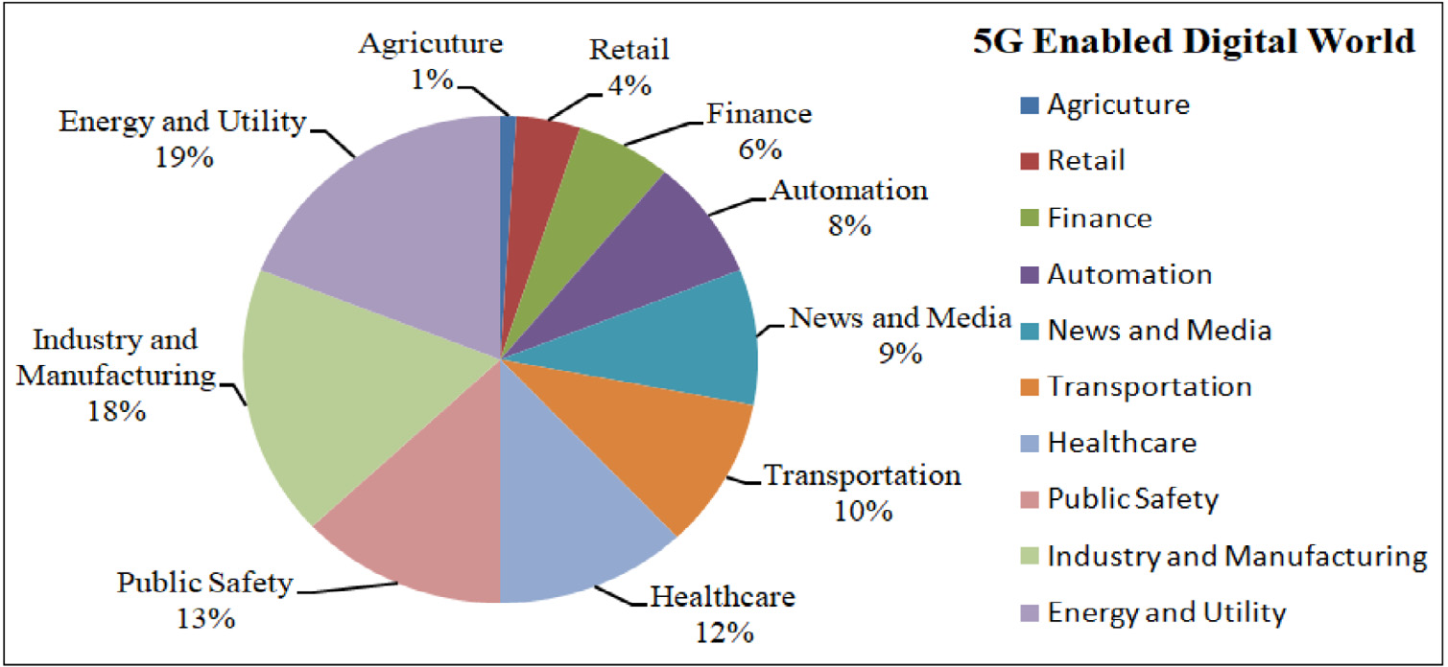

**Fig. 1.** Sectors that win the most from 5G technology [24].

**Table 2**   
Impacts of 5G enabled digital technologies in healthcare.

5G enabled digital technologies in confronting the COVID-19 pandemic

|  |  |  |  |  |
| --- | --- | --- | --- | --- |
| AI [33] | IoT [22] | Big data [34] and Cloud computing [35] | Robots and Robotic technology [36] | AR and VR [37] |
| Analyzing real-time health data and improving diagnosis  procedures | Rapidly expanding the number of connected devices and  providing a diversity of  healthcare solutions | Allowing more data to be  transmitted quickly and more reliably to the cloud | Deploying to limit human  resources, to relieve pressure, and support effective care | Deploying new consumer devices that support more advanced AR and VR apps |

Moreover, 5G technology is anticipated to connect billions of de-vices with improved performance, and 5G supported applications have the potential to deliver transformative impacts in various sectors (see Table 1), such as healthcare, education, resource management, trans-portation, agriculture, etc. to handle the challenges caused the COVID-19 pandemic [22,23]. It is estimated that 5G enabled digital market revenues will be USD 1.3 trillion by 2026, and sectors that use most 5G technology is shown in Fig. 1 [24]. Since 2020 the world is the COVID-19 related health crisis, the 5G combined with other advanced digital technologies (see Table 2) can support to tackle the coron-avirus challenges in healthcare [25]. These digital technologies includ-ing the ‘‘internet of things (IoT)’’ [26,27], ‘‘big-data analytics’’ [28],‘‘artificial intelligence (AI)’’ that uses ‘‘machine learning’’ and ‘‘deep learning’’ [29,30], and ‘‘blockchain technology’’ [31], are highly inter-related and will be more effective with 5G technology in healthcare applications. This innovative 5G technology will transform together speedy connectivity, cloud-based storage, billions of smart devices, and enhanced medical services in healthcare sector. Thus, 5G will transform the healthcare sector and enable more than USD 1.1 trillion in economic output in 2035 [32].

The 5G enabled digital technology can aid more effective medi-cal research, diagnose and treatment, as well as improved healthcare services for both medical professionals and patients in anywhere–anytime [38]. Fig. 2 illustrates a simple 5G based health platform that assists both the patients and the medical professionals [39]. Since 5G promises super-speed (about 100Mbs) with high data bandwidth and low latency, AI like advanced technologies implemented in 5G networks can enable an intelligent and autonomous functionality to

2

*M.M. Rahman et al.*  *Array 14 (2022) 100178*

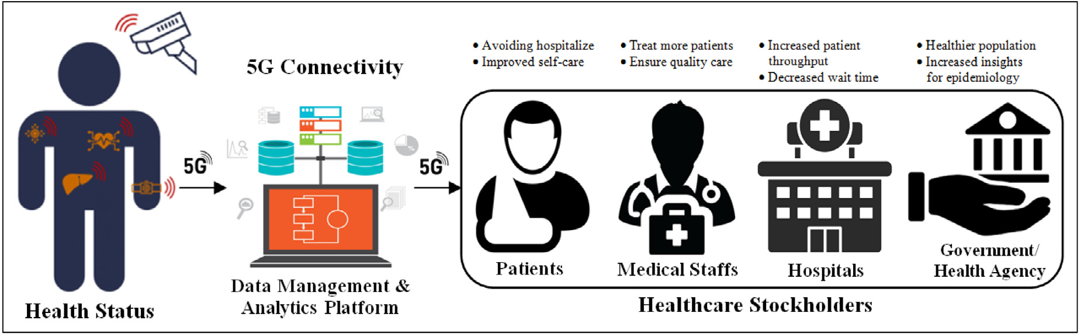

**Fig. 2.** A simple 5G based health platform for remote patient monitoring and treatment [39].

**2. Background**

*2.1. 5G-coronavirus false theory*

Each generation of wireless network standard has introduced a new era of telecommunication, and offered improved data-flow capability and latency. The mobile network just began with first generation (1G) in 1980s, 2G represented the digital transmission in 1991, 3G introduced the mobile telephony world in 2000s, 4G introduced the Streaming Era in 2009, and the latest 5G technology is being introduced the Internet of Things Era [51]. But it was asserted that 3G was deployed in 2003 as the year of the SARS epidemic, 4G was first established in 2009 as the year of the swine flu pandemic, and finally, 5G network was introduced in 2019 that is the year of the COVID-19 outbreak [13,52]. But the truth is that 3G was first unrolled in Japan in 2001 and Japan was not affected at that time. According to the ‘‘World Health Organization (WHO)’’ reports, in 2002 the SARS outbreak began in China before unrolling 3G. In late 2009, 4G network first launched in Sweden and Norway [53]. The Swine flu evolved by the H1N1 influenza virus that was first identified in April 2009 in Mexico and the United States before 4G deployment [54,55]. The first COVID-19 case was identified in China on December 31, 2019, and the coronavirus has rapidly spread around the world in 2020. But 5G was first launched in South Korea on December 1, 2018 [56]. The emerged date of 5G-coronavirus matching is coincidence. Many countries without having 5G networks have seriously affected by the coronavirus [57–59]. Al-though 3G, 4G and 5G networks were unrolled at the same years to the SARS, H1N1 influenza virus and novel coronavirus outbreaks, the WHO reported that is no scientific study could link between the wireless technology and the virus outbreak [60].

*2.2. Impact of the COVID-19 epidemic*

The world is still now a health emergency situation due to the COVID-19 caused by the novel coronavirus, which was provisionally named ‘‘2019 novel coronavirus (2019-nCoV)’’ by the WHO in Decem-ber 2019. Several studies showed that the 2019-nCoV is considered a new human-infecting betacoronavirus [61], and allied with mild clin-ical symptoms of (i) ‘‘severe acute respiratory syndrome (SARS) coro-navirus (SARS-CoV)’’ [62], a novel betacoronavirus that first emerged in China in 2002 [63,64], and (ii) ‘‘middle east respiratory syndrome (MERS) coronavirus (MERS-CoV)’’, was first identified in Saudi Arabia in 2012 [65]. Till now (April 5, 2021) the 2019-nCoV has been reported in 219 countries with 132 millions confirmed cases of ‘‘human-to-human transmission’’ [66]. The outbreak of COVID-19 declared as a pandemic that affected our socio-economic environments and all the sectors of healthcare, tourism and hospitality, education, aviation and transportation, manufacturing and distribution, agriculture and supply chain, electronics and energy, financial markets, etc. It was estimated

3

*M.M. Rahman et al.*  *Array 14 (2022) 100178*

**Table 3**

Impacts of the pandemic on the existing wireless networks.

Impact of COVID-19 on the usage of telecommunication networks

|  |  |  |  |  |
| --- | --- | --- | --- | --- |
| Capacity limitation [77] | Service disruption [78] | Energy wastage [79] | Cell outages [23] | Rural-connectivity limitation [80] |
| Increasing network dependency by many sectors, Surging traffic demand and demand shift to residential areas | Increasing demand for high  mobility support, Poor support for high mobility broadband services, Need for health  services | Increasing number of  underutilized base station due to shifting traffic demand, Lack of autonomous base station  switching mechanisms | Reducing the number of on-site workers, Attack on telecom  engineers on-site, Damage to base station equipment | Limiting in deployment of  network, Erratic electricity  supply, Low profit compared to investment |

*2.3. Current healthcare system*

The existing healthcare system is facing a number of challenges and problems. Major global challenges include lack of healthcare services and facilities, lack of digital resources and limited access, lack of quality treatment and high costs, lack of digital devices and systems, etc. [17,81].

I. **Challenges with EHRs and Universal Access:** The ‘‘Electronic Health Record (EHR)’’ stores patient’s health information elec-tronically that can be shared securely with multiple users to provide quality service in integrated health from anywhere in the world [82,83]. The main problem in the existing system is that hospitals and medical staffs are not connected to the EHR system, and thus, the patients‘‘ô record is constrained within clinics and laboratories. In poor and developing countries, the deployment of universal healthcare system is very challenging due to several reasons such as limited medical equipment and resources, lack of skilled professionals, as well as poor people unable to afford medical services [84,85].

II. **Limited Resources and Healthcare Facilities:** Many countries are now suffering the insufficient medical services in fighting the COVID-19 outbreak due to shortage of hospitals and ac-commodation, insufficient healthcare supplies and medications, shortage of skilled staffs and digital systems. About 57 countries are seriously facing the shortage of medical professionals [84, 86], and it is estimated that the world will have a lack of 12.9 million healthcare staffs by 2035 [87]. Thus, it requires the deploying of telemedicine and e-Heath services to support medical staffs as well as patients.

III. **Challenges in Health Information Systems:** As the existing healthcare is suffering troubles in universal health information systems, the development of ‘‘information communications tech-nology (ICT)’’ tools will have a great transformation in the whole healthcare system. It can connect multiple medical devices and equipment, process heterogeneous health data, optimum allo-cate available resources, automate financial transactions and management to provide efficient healthcare services, like remote surgery, wellness monitoring applications, etc. [88,89].

IV. **Lacks in Developing Intelligent Healthcare Solutions:** The existing healthcare is suffering for poor data-driven practices in patients assessment in which both patients and staffs are restricted to utilize proper medication procedure and digital de-vices [90]. It sometimes causes over-or under-estimated effects of undesirable drug reaction. The development of intelligent healthcare solutions can provide the best care to the patients as well as to ensure safe and quality services.

*2.4. 5G technology and health issues*

5G follows the advancement of 2G, 3G and 4G wireless network standards [91,92]. 2G was suitable for calls and text-messages with very-low speed. Beside calls and messaging, 3G also supported data and the Internet services with the speed over 5 Mbps. The existing 4G network supports faster connectivity with the speed over 10 Mbps,

4

*M.M. Rahman et al.*  *Array 14 (2022) 100178*

*2.5. 5G healthcare opportunities*

5G connectivity is improving the healthcare services in different ways [17] by enabling home healthcare, digitizing pathological anal-ysis, handling patients’ information files, enabling remote surgery and medications, enabling healthcare training and therapeutic, enabling secure staff–patient communication and management, etc. [107,108]. The promising aspects of 5G will also have the strength in the future of medicine and treatment advancement [109], and the utilization of advanced technology in healthcare has been reviewed in several studies [110–113]. A few aspects of the newly commercialized 5G tech-nology relevant to healthcare services, that have potential influences in limiting the COVID-19 pandemic, are highlighted below.

I. **In-home Healthcare Services:** Due to limited number of hospi-tals, high costs and long waiting in the pandemic, the patients want to be treated at home, if they are not seriously affected. 5G is helping to improve the home healthcare services, like online health consultancy, remote health monitoring via digital devices over a secured 5G mobile network.

II. **Digital Pathological Analysis:** 5G is being supporting to de-velop smart hospitals by improving digital pathology and di-agnosis. The healthcare has already experienced the 5G pow-ered computed tomography (CT) scanning remotely in real time [114]. The medical specialists will be able to utilize 5G net-works to access the large volume of health data obtained during diagnosis or surgery from anywhere in any time.

III. **Remote Surgery and Medications:** The promising features of 5G will revolutionize on online treatments and surgery. The 5G healthcare innovations include telemedicine, tele-surgery or robotic-surgery, remotely emergency care, etc. The 5G based telemedicine provides a remote consultation platform, in which the health professionals can treat the patients effectively. The tele-surgery provides a real-time operation, and the surgeons can perform remote surgery using surgical devices through 5G networks [115]. 5G connected ambulances or mobile clinics in rural areas could enable AR assisted operations to serve the patients with appropriate critical care.

IV. **Healthcare Training and VR Therapy** 5G also augments the prospect for distant training with audio–visual and real-time communication. Virtual reality (VR) with 5G has already trans- formed many aspects in healthcare industry. The medical profes- sionals and students are using 5G enabled high-end VR to simu- late operations, and clinics are using an innovative VR therapy to assist patients, recover from chronic pain or injuries [116]. V. **Healthcare Research and Education:** The 5G technology rev- olutionizes the link among researchers/scientists, patients, and medical centers. It will be achieved by establishing the envi- ronment with 5G based IoT and ICT tools, intelligent platforms, multi-access edge computing (MEC), cloud computing and big- data analytics to power the facility for research, treatment and wellness education [117].

*2.6. 5G enabled technologies in healthcare*

Now-a-days, the advanced digital technologies are being trans-formed in healthcare to handle the world epidemic COVID-19 [118]. The promising 5G enabled digital technologies, such as IoT, AI, Big Data Analytics and Cloud Computing, Blockchain, etc. have been augmented the public-health strategies [25] to fix the current healthcare limita-tions and confront the coronavirus disease (COVID-19) pandemic [34].

I. **IoT Aided Healthcare Advancement:** We are observing the growth of IoT aided systems, and it is projected that more than 20 billion devices/sensors will be allied to the Internet by 2020 [119]. These devices can convey information to the cloud

5

*M.M. Rahman et al.*  *Array 14 (2022) 100178*

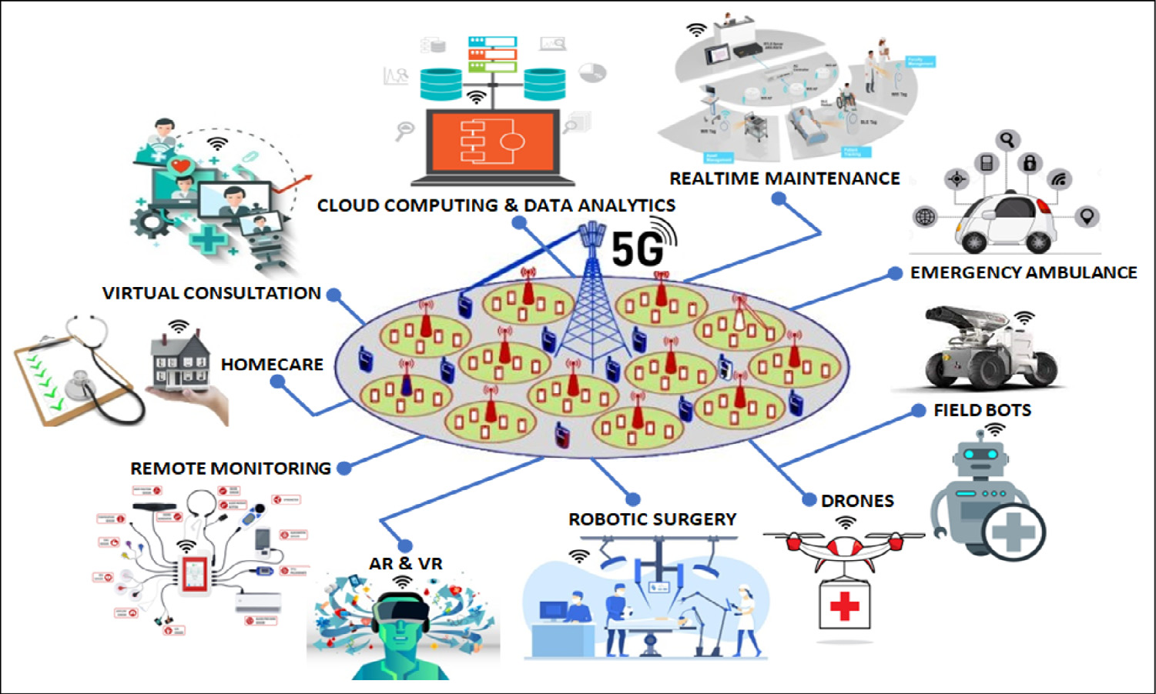

**Fig. 3.** Few aspects of 5G interconnected technologies in healthcare to tackle the pandemic [140].

I. **Telemedicine:** Telemedicine requires a reliable and faster net-work connectivity that will offer quality video and real-time communication. 5G standards can enable proper telemedicine environment that augments online health consultancy [141].

It is estimated that the telemedicine market will raise yearly growth of 16.5 percent from 2017 to 2023 in healthcare [47]. 5G also meets the teleconferencing requirements to enable medical experts to treat patients efficiently from anywhere in anytime. II. **Telesurgery:** As 5G is a very-low latency and super-fast network, it enables telesurgery or remote medical operation. A health surgeon in China first performed a 5G-assisted remote surgery using da Vinci surgical robots on animal in January 2019 [142].

In March 2019, a telesurgery using 5G mobile network was first performed remotely on human brain in China [115]. Moreover, 5G capabilities can improve the surgical robots and robotic pro-cess that can enhance the surgeon’s capabilities in the pandemic. III. **Internet of Medical Things (IoMT):** 5G network infrastructure is able to connect a billion of digital devices and wearable med-ical equipments (i.e., IoMT objects) that allow a link between physical and digital worlds, and facilitate real-time analytics to improve health outcomes. It can gather a large volume of health data and store on a cloud as well as assist online accessibility to the users, medical professionals and researchers. The world has already experienced a number of IoMTs and health applications (for instant, 5G thermal imaging systems, smart diagnostic tools, therapeutic kits, etc.) as a part of the emerging 5G innovations in the pandemic [138,143,144].

IV. **Remote Diagnosis and Treatment:** 5G connectivity is rev-olutionizing in continuous contagion monitoring and remote diagnosis from anywhere in this pandemic [132,145]. It also enables digital medicine that can share a high-volume of health information across a worldwide network of health specialists for caring patients. In January 2020, China has first developed 5G remote diagnosis and treatment system [146] that can support remote diagnosis and treat patients in this pandemic.

V. **Digitized and Data-Driven Platforms:** Many developed coun-tries, like China, Japan, South Korea and the US, are rapidly set up their specific 5G wireless networks for digitalized, data-driven and Cloud-based emergency platforms that can assist the COVID-19 treatment in hospitals [147,148]. These digital plat-forms support the healthcare systems in the context of improved response times, remote monitoring, data analysis and diagnosis, resource allocation, etc.

6

*M.M. Rahman et al.*  *Array 14 (2022) 100178*

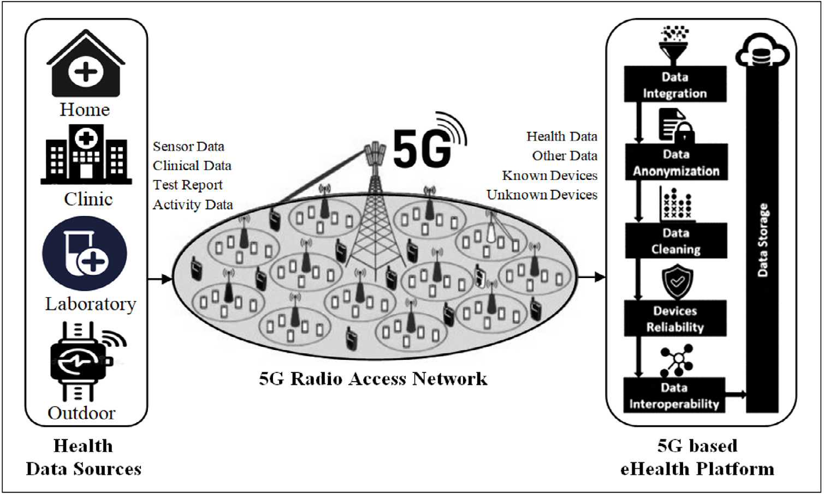

**Fig. 4.** A typical architecture of 5G enabled eHealth Platform [45].

platform has been developed using an appropriate integra-tion of ‘‘virtual network functions (VNFs)’’ [153,154] and‘‘software defined network (SDN)’’ [155] technologies. This platform is able to offer network virtualization, automation and creation of new services over virtual resources.

Step 3. **Data Management Mechanisms and Storage:** The 5G SDN with virtual networking platform provides all the data man-agement mechanisms, such as data integration, data anonym-ization, data interoperability etc. All the gathered data after transformations (such as, data integration [156], anonymiza-tion [157], cleaning [158], source reliability [159], and data interoperability [160] procedures) is transfigured to a com-mon format, and reserved into the eHealth database. This transformation is a prerequisite for the effective Health plat-form, which can support the virtualization of different eHealth platforms running in different entities, such as in-home, hos-pitals, clinics, laboratories, etc.

*3.2.2. Real-time mobile health (mHealth) platforms*   
 It is very important to know about the public-health related in-formation to forecast the outbreak during the different phases of the epidemic. Mobile technology can assist the estimation of the viral outbreak, and provide emergency treatment during the pandemic. A eHealth platform using mobile technology is referred to as mHealth (mobile health) system. A simple mHealth system is graphically pre-sented in Fig. 5 [159] that enables to connect a variety of digital devices, such as smartphone, tablet, iPad, smartwatch, wearable, etc. It can share the health information and applications to treat the pa-tients in the emergency situations. These devices are generally con-nected through Wi-Fi, ‘‘global positioning system (GPS)’’, and high-speed telecommunication networks (5G networks).

Thus, the mHealth system using 5G wireless network and cloud-based technologies can support to enhance the emergency treatment, health research activities, and other healthcare services in the COVID-19 pandemic [161,162]. Some of the potential services of the mHealth platforms are highlighted below:

(i) Video conferencing and text messaging, through which a patient can consult a doctor to get precise guidance for the distant treatment.

(ii) Contract tracing, through which the patient database can be used for tracing infected patient’s location in case of communal spread of the coronavirus disease.

7

*M.M. Rahman et al.*  *Array 14 (2022) 100178*

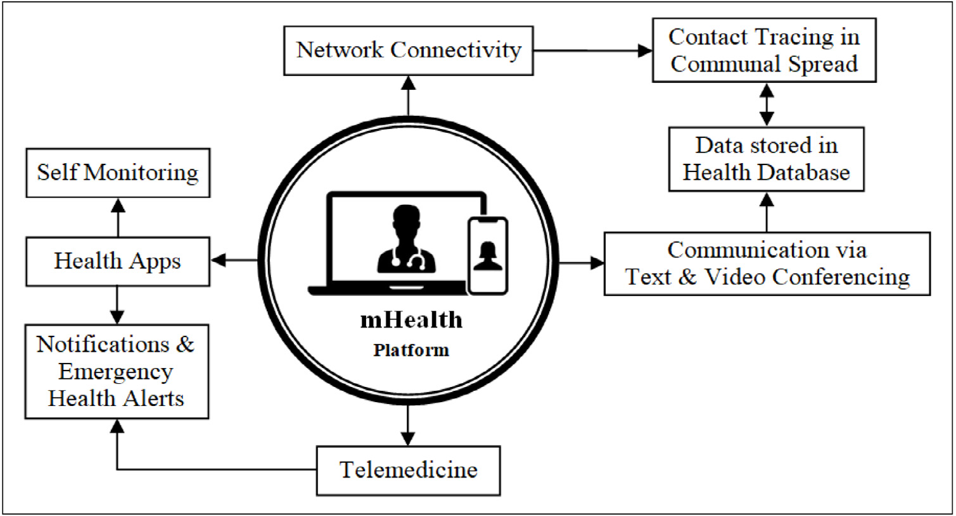

**Fig. 5.** mHealth in various application domains.

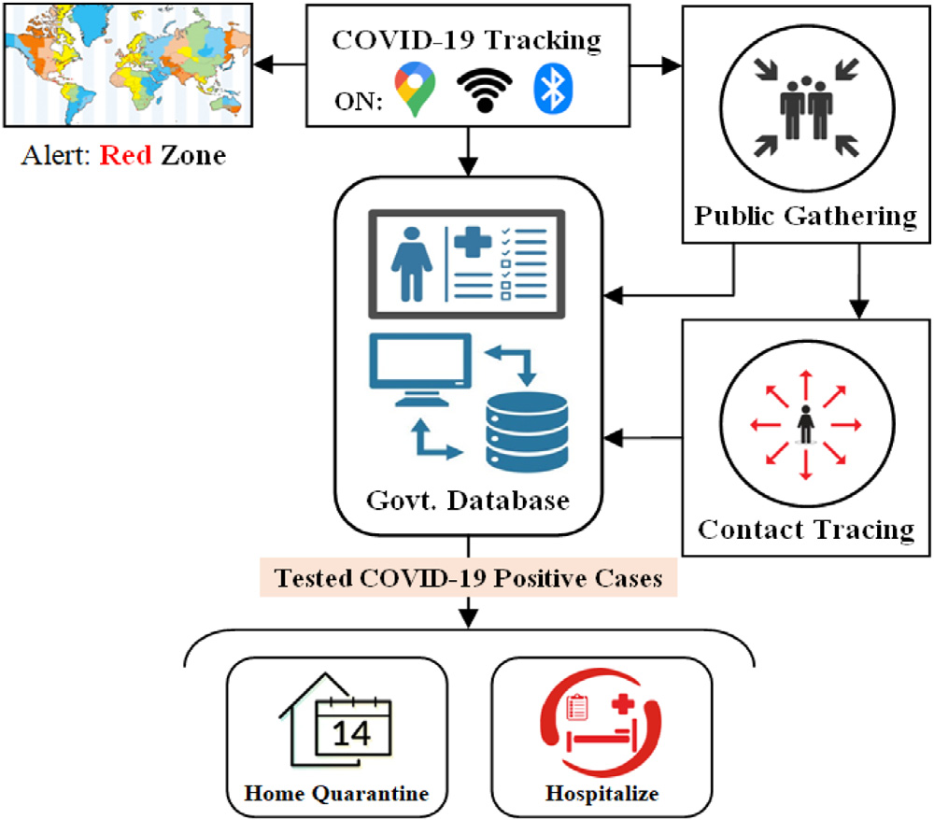

**Fig. 6.** Illustration of mobile technology based COVID-19 tracking system.

using virtual platforms [169]. Fig. 7 illustrates a typical telemedicine process lifecycle that starting with reading telemedicine information and patient registration, and ending with the future follow-up appoint-ment for monitoring patient’s health [141].

Though the doctors utilize virtual platform during online consulta-tion, they try to create the almost real environment as much possible, and maintain confidentiality patient’s privacy and agreement [170]. During online session, they must keep professionality in nature and build a patient–physician relationship [170–172]. They also ensure the telemedicine service within the patient’s health coverage. The patients also will be notified if they use any third-party application during vir-tual consultation regarding the privacy or cyber security issues. Beside high-speed network, the system requires better supporting tools, like smart devices with camera and microphones, proper lighting, noise-free environment, etc., for virtual examination at the both ends [172,173]. Telemedicine ensures a user-friendly and comfortable virtual platform for both the patients and the doctors as well as provides an improved virtual treatment process.

8

*M.M. Rahman et al.*  *Array 14 (2022) 100178*

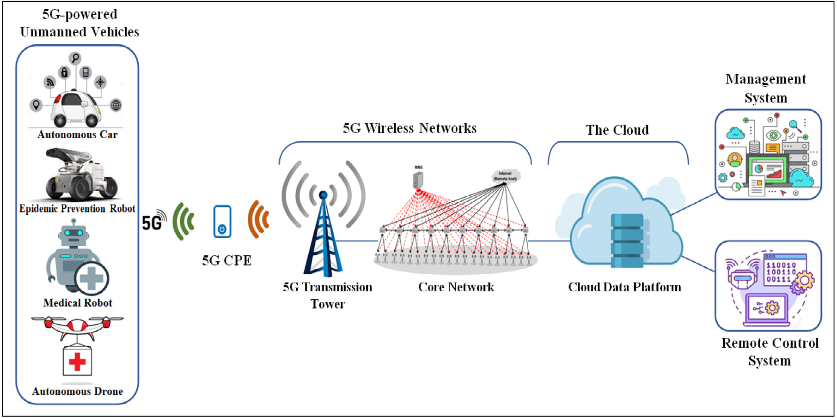

**Fig. 8.** 5G Enabled Unmanned-Vehicle Automation System [112].

The 5G-enabled robots and drones with smart vision sensors have been utilized to patrol the risks zones. They have the ability to track multiple target objects simultaneously while patrolling. They can also monitor the spread of sickness, notify public to wash their hands, detect and notify for wearing masks, etc.

B. **Unmanned Cars:** The self-driving vehicles or unmanned cars are being employed to avoid contact between individuals at infected areas, which greatly reduces the risk of infection. In-tegrating 5G and autonomous driving technology, the cars can perform fully automated and contact-free tasks with improved efficiency [177]. This vehicle is connected to the remote server through 5G network, and used as an intelligent system for dis-infection, transportation, patrolling, epidemic prevention broad-casting, etc.

C. **5G Intelligent Robots:** Another type of intelligent robot by integrating 5G and AI technology assists medical professionals to conduct consultations, disinfection, cleaning, and deliver-ies [178]. The usage of these smart robots can effectively relieve shortages of staffs, which reduce the risks of cross-infection and improve the quarantine-control in the medical centers.

D. **5G-powered Disinfection Robots:** The 5G-powered disinfec-tion robot is designed with a spray sterilization system that can effectively disinfect the contagious area [179]. It can effort autonomously in accordance with a settled disinfection route, setting time, fixed-points, multi-track mobile disinfection and sterilization in the contagious world [180]. Thus, robots are increasingly being deployed at the front lines against the COVID-19 pandemic in order to reduce cross-infection risks and improve work efficiency and quality [181].

E. **5G-powered Intelligent Drones:** 5G-powered drones with AI technology are being utilized for drugs delivery and aerial spray-ing for disinfection in the virus affected areas [182]. They are being also used to transport samples from patients to medical workers, thus reducing the COVID-19 contagion risks.

**4. Challenges and prospective**

The real-time super-speed and very-low latency aspects of 5G net-work offers a variety of new opportunities that support to expand healthcare applications. The literature shows that 5G enabled tech-nologies have the incredible potentials in healthcare to confront the

9

*M.M. Rahman et al.*  *Array 14 (2022) 100178*

data and device protection, data filtering and digital rights man-agement, patient’s data confidentiality, infrastructure and na-tional security, network security, cybercrime and cyber-security, etc. [186,187].

*4.2. Prospective*

I. **Super-Fast and Accurate Health Services:** The super-fast 5G network can provide quick and reliable transport of large med-ical data. Low latency feature of 5G technology can provide faster and reliable treatment to the patients remotely, and help surgeons for conducting remote robotic-surgery.

II. **Advancements in Healthcare:** 5G technology can improve per-sonalized and preventive care. 5G powered telemedicine en-ables real-time health consultancy and emergency treatment.

Moreover, a fully-implemented 5G network will enhance med-ical operations and management as well as quality treatment experiences for both the patients and medical staffs.

III. **Integration of Advanced Technologies:** 5G is being given us the opportunity to utilize ‘‘artificial intelligence (AI)’’, ‘‘Internet of medical things (IoMT)’’, ‘‘augmented reality (AR)’’, ‘‘virtual reality (VR)’’ in healthcare applications. They have the potentials to offer innovative and transformative health facilities as well as enhance real-time treatment and diagnosis procedures.

IV. **Cost Optimization and Safeguard Quality:** The use of 5G-powered technologies, like mHealth technology, telemedicine, IoMTs and wearable devices, or digital health platforms [188] can help patient’s living in urban and rural areas by gain-ing remote access to medical assistance [189]. It will obvi-ously save money by avoiding expensive hospital visit without compromising quality-treatment [190]. It will also offer distant doctor-assistance on diagnosis, and will fulfill the desired service standards for a complete medicinal examination [191].

V. **Advancements in Intervention Management and Adminis-trative Operations:** The new insights of 5G-powered healthcare solutions will provide continuity of health caring without having interrupt in data entry and querying tasks, thus, it is a disruptive process in recording medical information [192,193]. It enables improvements in intervention management by facilitating valu-able healthcare resources, like operating theaters, electrocardio-gram monitors, and other medical equipments. These valuable assets enable better management as well as ensure safe and efficient administrative operations.

**5. Conclusion**

The use of 5G network in integrating other digital technologies (like AI and machine learning, IoMTs, big data analytics, cloud computing, etc.) is now a reality in healthcare. From the literature, it is clear that 5G enabled technologies as well as intelligent systems have a prospect to improve healthcare services, such as medical diagnosis, health mon-itoring, treatment, management, etc. As the 5G poses non-ionizing radiation, there is no significant health risk of 5G RF wave below the recommended safety level. There is no evidence that 5G signal causes the spread of the coronavirus. Moreover, 5G enabled digital technolo-gies have been used for limiting the COVID-19 outbreak, and enhancing the public-health strategies in 2020. Some advanced technology giants are conducting their researches on 5G related applications that will combat against the health risks of any undesirable epidemics. The successful utilization of 5G technology to tackle healthcare challenges will enhance the acceptance of such technologies for other sectors in the future.

As it is a new field of research, some issues are to be considered in deployment of 5G network in healthcare including infrastructure development, technical standards, effective regulations and policy, pri-vacy protection and security, as well as availability of research data.

10

*M.M. Rahman et al.*  *Array 14 (2022) 100178*

[21] [Tang Y, Dananjayan S, Hou C, Guo Q, Luo S, He Y. A survey on the 5G network and its impact on agriculture: Challenges and opportunities. Comput Electron Agric 2021;180:105895.](http://refhub.elsevier.com/S2590-0056(22)00036-4/sb21)

[22] [West DM. How 5G tech](http://refhub.elsevier.com/S2590-0056(22)00036-4/sb21)[nology enables the health internet of things. 2016, p.](http://refhub.elsevier.com/S2590-0056(22)00036-4/sb22)  [1–20, Brookings Center for Technology Innovation, 3.](http://refhub.elsevier.com/S2590-0056(22)00036-4/sb22)

[23] [Abubakar AI, Omeke KG, Öztürk M, Hussain S, I](http://refhub.elsevier.com/S2590-0056(22)00036-4/sb22)mran MA. The role of artificial intelligence driven 5G networks in COVID-19 outbreak: opportunities, challenges, and future outlook. Front Commun Netw 2020;1. [http://dx.doi.org/ 10.3389/frcmn.2020.575065](http://dx.doi.org/10.3389/frcmn.2020.575065).

[24] [Martynova O. Top uses of 5](http://dx.doi.org/10.3389/frcmn.2020.575065)G in the energy sector. 2019, Online; [https://www.](https://www.intellias.com/top-uses-of-5g-in-the-energy-sector/)  [intellias.com/top-uses-of-5g-in-the-energy-sector/](https://www.intellias.com/top-uses-of-5g-in-the-energy-sector/). [Accessed 2 A[pril 2021].](https://www.intellias.com/top-uses-of-5g-in-the-energy-sector/)

[25] [Ting DSW, Carin L, Dzau V, Wong TY. Digital te](https://www.intellias.com/top-uses-of-5g-in-the-energy-sector/)[chnology and COVID-19. Nat](http://refhub.elsevier.com/S2590-0056(22)00036-4/sb25)  [Med 2020;26(4):459–61.](http://refhub.elsevier.com/S2590-0056(22)00036-4/sb25)

[26] [Mohammed IB, Isa SM.](http://refhub.elsevier.com/S2590-0056(22)00036-4/sb25) [The role of internet of things (IoT) in the containment and spread of the novel COVID-19 pandemic. In: Computational intelligence methods in COVID-19: surveillance, prevention, prediction and diagnosis. Springer; p. 109–19.](http://refhub.elsevier.com/S2590-0056(22)00036-4/sb26)

[27] [Perkel](http://refhub.elsevier.com/S2590-0056(22)00036-4/sb26)  [JM.](http://refhub.elsevier.com/S2590-0056(22)00036-4/sb26)  [The](http://refhub.elsevier.com/S2590-0056(22)00036-4/sb26)  [Internet](http://refhub.elsevier.com/S2590-0056(22)00036-4/sb27)  [of](http://refhub.elsevier.com/S2590-0056(22)00036-4/sb27)  [Things](http://refhub.elsevier.com/S2590-0056(22)00036-4/sb27)  [comes](http://refhub.elsevier.com/S2590-0056(22)00036-4/sb27)  [to](http://refhub.elsevier.com/S2590-0056(22)00036-4/sb27)  [the](http://refhub.elsevier.com/S2590-0056(22)00036-4/sb27)  [lab.](http://refhub.elsevier.com/S2590-0056(22)00036-4/sb27)  [Nature](http://refhub.elsevier.com/S2590-0056(22)00036-4/sb27)  [2017;542(7639):125–6.](http://refhub.elsevier.com/S2590-0056(22)00036-4/sb27)

[28] [Shilo S, Rossman H, Se](http://refhub.elsevier.com/S2590-0056(22)00036-4/sb27)[gal E. Axes of a revolution: challenges and promises of](http://refhub.elsevier.com/S2590-0056(22)00036-4/sb28)  [big data in healthcare. Nat Med 2020;26(1):29–38.](http://refhub.elsevier.com/S2590-0056(22)00036-4/sb28)

[29] [LeCun Y, Bengio Y, Hinton G. Deep learning. Natu](http://refhub.elsevier.com/S2590-0056(22)00036-4/sb28)[re 2015;521(7553):436–44.](http://refhub.elsevier.com/S2590-0056(22)00036-4/sb29) [30] [Ting DS, Liu Y, Burlina P, Xu X, Bressler NM, Wong TY. AI for medical imaging](http://refhub.elsevier.com/S2590-0056(22)00036-4/sb29) [goes deep. Nat Med 2018;24(5):539–40.](http://refhub.elsevier.com/S2590-0056(22)00036-4/sb30)

[31] [Heaven D. Bitcoin for the biological lite](http://refhub.elsevier.com/S2590-0056(22)00036-4/sb30)[rature. Nature 2019;566(7742):141.](http://refhub.elsevier.com/S2590-0056(22)00036-4/sb31) [32] [Valencia R. Previewing 5G’s effect on the health care industry. 2017, Onli](http://refhub.elsevier.com/S2590-0056(22)00036-4/sb31)ne; [https://www.qualcomm.com/news/onq/2017/10/30/previewing-5gs-effect-](https://www.qualcomm.com/news/onq/2017/10/30/previewing-5gs-effect-health-care-industry) [health-care-industry. [Accessed 4 April 2021].](https://www.qualcomm.com/news/onq/2017/10/30/previewing-5gs-effect-health-care-industry)

[33] [Shi F, Wang J, Sh](https://www.qualcomm.com/news/onq/2017/10/30/previewing-5gs-effect-health-care-industry)[i J, Wu Z, Wang Q, Tang Z, et al. Review of artificial intelligence techniques in imaging data acquisition, segmentation and diagnosis for covid-19. IEEE Rev Biomed Eng 2020.](http://refhub.elsevier.com/S2590-0056(22)00036-4/sb33)

[34] [Soldani D. Fighting pandemics by expl](http://refhub.elsevier.com/S2590-0056(22)00036-4/sb33)[oiting 5G, AI and bigdata enabled technologies: How 5G can help contain the spread of COVID-19. J Telecommun Digit Econ 2020;8(2):146.](http://refhub.elsevier.com/S2590-0056(22)00036-4/sb34)

[35] [Chettri S, Debnath D, D](http://refhub.elsevier.com/S2590-0056(22)00036-4/sb34)evi P. Leveraging digital tools and technologies to alleviate COVID-19 pandemic. 2020, Available At SSRN: [http://dx.doi.org/10. 2139/ssrn.3626092](http://dx.doi.org/10.2139/ssrn.3626092).

[36] [Zemmar A, Lozano](http://dx.doi.org/10.2139/ssrn.3626092) [AM, Nelson BJ. The rise of robots in surgical environments](http://refhub.elsevier.com/S2590-0056(22)00036-4/sb36)  [during COVID-19. Nat Mach Intell 2020;2(10):566–72.](http://refhub.elsevier.com/S2590-0056(22)00036-4/sb36)

[37] [Agarwal S, Punn NS, Sonbhadra SK, Nagabhushan P](http://refhub.elsevier.com/S2590-0056(22)00036-4/sb36), Pandian K, Saxena P.

Unleashing the power of disruptive and emerging technologies amid covid 2019: a detailed review. 2020, arXiv preprint[arXiv:2005.11507](http://arxiv.org/abs/2005.11507).

[38] [Angelucci A, Kuller D, Aliverti A. A ho](http://refhub.elsevier.com/S2590-0056(22)00036-4/sb38)[me telemedicine](http://arxiv.org/abs/2005.11507) [system for continuous](http://refhub.elsevier.com/S2590-0056(22)00036-4/sb38)  [respiratory monitoring. IEEE J Biomed Health Inform 2020.](http://refhub.elsevier.com/S2590-0056(22)00036-4/sb38)

[39] [STLPartners. 10 5G Healthcare use cases transforming dig](http://refhub.elsevier.com/S2590-0056(22)00036-4/sb38)ital health. 2020, [https://stlpartners.com/digital-health-telecoms/10-5g-healthcare-use-](https://stlpartners.com/digital-health-telecoms/10-5g-healthcare-use-cases/)Online;   
 [cases/](https://stlpartners.com/digital-health-telecoms/10-5g-healthcare-use-cases/). [A[ccessed 4 April 2021].](https://stlpartners.com/digital-health-telecoms/10-5g-healthcare-use-cases/)

[40] [Klaine](https://stlpartners.com/digital-health-telecoms/10-5g-healthcare-use-cases/) [PV, Imran MA, Onireti O, Souza RD, Tutorials. A survey of machine learning techniques applied to self-organizing cellular networks. IEEE Commun Surv 2017;19(4):2392–431.](http://refhub.elsevier.com/S2590-0056(22)00036-4/sb40)

[41] [Letaief KB, Chen W, Shi](http://refhub.elsevier.com/S2590-0056(22)00036-4/sb40) [Y, Zhang J, Zhang Y-JA. The roadmap to 6G: AI](http://refhub.elsevier.com/S2590-0056(22)00036-4/sb41)  [empowered wireless networks. IEEE Commun Mag 2019;57(8):84–90.](http://refhub.elsevier.com/S2590-0056(22)00036-4/sb41)

[A.](http://refhub.elsevier.com/S2590-0056(22)00036-4/sb41)  [How](http://refhub.elsevier.com/S2590-0056(22)00036-4/sb41)  [will](http://refhub.elsevier.com/S2590-0056(22)00036-4/sb41)  [5G](http://refhub.elsevier.com/S2590-0056(22)00036-4/sb41)  [impact](http://refhub.elsevier.com/S2590-0056(22)00036-4/sb41)  [different](http://refhub.elsevier.com/S2590-0056(22)00036-4/sb41)  [industries?.](http://refhub.elsevier.com/S2590-0056(22)00036-4/sb41)  [2018,](http://refhub.elsevier.com/S2590-0056(22)00036-4/sb41)  Online; [42] [Baskaran](http://refhub.elsevier.com/S2590-0056(22)00036-4/sb41)   
 PreScouter Newsletter, [https://www.prescouter.com/2018/01/5g-impact-](https://www.prescouter.com/2018/01/5g-impact-different-industries/#:~:text=According%20to%20a%20report%20by,of%20traffic%20and%20reducing%20collisions) [different-industries/#:~:text=According%20to%20a%20report%20by,of%](https://www.prescouter.com/2018/01/5g-impact-different-industries/#:~:text=According%20to%20a%20report%20by,of%20traffic%20and%20reducing%20collisions)  [20traffic%20and%20reducing%20collisions. [Accessed 12 March 2021].](https://www.prescouter.com/2018/01/5g-impact-different-industries/#:~:text=According%20to%20a%20report%20by,of%20traffic%20and%20reducing%20collisions)

[43] [Chang LF. Journey to 5G. In: 2019 internati](https://www.prescouter.com/2018/01/5g-impact-different-industries/#:~:text=According%20to%20a%20report%20by,of%20traffic%20and%20reducing%20collisions)[onal symposium on VLSI technology,](http://refhub.elsevier.com/S2590-0056(22)00036-4/sb43)  [systems and application. IEEE; p. 11.](http://refhub.elsevier.com/S2590-0056(22)00036-4/sb43)

[44] [Verizon. The journey to 5G. 2018, O](http://refhub.elsevier.com/S2590-0056(22)00036-4/sb43)nline; [https://www.healthcareitnews.com/](https://www.healthcareitnews.com/news/journey-5g)  [news/journey-5g](https://www.healthcareitnews.com/news/journey-5g). [Accessed 17 August 202[0].](https://www.healthcareitnews.com/news/journey-5g)

[45] [Mavrogiorgou A](https://www.healthcareitnews.com/news/journey-5g)[, Kiourtis A, Touloupou M, Kapassa E, Kyriazis D, Themis-tocleous M. The road to the future of healthcare: transmitting interoperable healthcare data through a 5G based communication platform. In: Euro-pean, Mediterranean, and Middle Eastern conference on information systems. Springer; p. 383–401.](http://refhub.elsevier.com/S2590-0056(22)00036-4/sb45)

[46] [Yuehong Y, Zeng Y, Chen X, Fan Y. The internet of things in healthcare: An](http://refhub.elsevier.com/S2590-0056(22)00036-4/sb46)  [overview. J Ind Inf Integr 2016;1:3–13.](http://refhub.elsevier.com/S2590-0056(22)00036-4/sb46)

[47] [Bekaroo G, Santokhee A, Augusto JC.](http://refhub.elsevier.com/S2590-0056(22)00036-4/sb46) [5G smart and innovative healthcare services: Opportunities, challenges, and prospective solutions. 5G Multimed Commun: Technol Multiserv Deployment 2020;279.](http://refhub.elsevier.com/S2590-0056(22)00036-4/sb47)

[48] [Moayedi G, Davis C. Insights in public health: Eq](http://refhub.elsevier.com/S2590-0056(22)00036-4/sb47)[uitable access to abortion care in Hawai ‘I: Identifying gaps and solutions. Hawai’I J Med Public Health 2018;77(7):169.](http://refhub.elsevier.com/S2590-0056(22)00036-4/sb48)

[49] [Rivezzi M, Tric](http://refhub.elsevier.com/S2590-0056(22)00036-4/sb48)[ase C, Rana RL. The telemedicine and ICT as tool to improve the local healthcare. In: New trends in sustainable business and consumption. Editura ASE; p. 1195–202.](http://refhub.elsevier.com/S2590-0056(22)00036-4/sb49)

[50] [West DM, Miller EA. Digita](http://refhub.elsevier.com/S2590-0056(22)00036-4/sb49)[l medicine: health care in the internet era. Brookings](http://refhub.elsevier.com/S2590-0056(22)00036-4/sb50)  [Institution Press; 2009.](http://refhub.elsevier.com/S2590-0056(22)00036-4/sb50)

[51] [Salih AA, Zeebaree SR,](http://refhub.elsevier.com/S2590-0056(22)00036-4/sb50) [Abdulraheem AS, Zebari RR, Sadeeq MA, Ahmed OM.](http://refhub.elsevier.com/S2590-0056(22)00036-4/sb51)

[Evolution of mobile wireless communication to 5G revolution. Technol Rep Kansai Univ 2020;62(5):2139–51.](http://refhub.elsevier.com/S2590-0056(22)00036-4/sb51)

11

*M.M. Rahman et al.*  *Array 14 (2022) 100178*

[81] Deloitte. 2017 Global health care sector outlook: Making progress against persistent challenges. 2017, Online; Deloitte Report, [https:](https://www2.deloitte.com/tr/en/pages/life-sciences-and-healthcare/articles/2017-global-health-care-sector-outlook.html)  [//www2.deloitte.com/tr/en/pages/life-sciences-and-healthcare/articles/2017-](https://www2.deloitte.com/tr/en/pages/life-sciences-and-healthcare/articles/2017-global-health-care-sector-outlook.html) [global-health-care-sector-outlook.html. [Accessed 30 November 2020].](https://www2.deloitte.com/tr/en/pages/life-sciences-and-healthcare/articles/2017-global-health-care-sector-outlook.html)

[82] [Häyrinen K, Saranto K, Nykänen P.](https://www2.deloitte.com/tr/en/pages/life-sciences-and-healthcare/articles/2017-global-health-care-sector-outlook.html) [Definition, structure, content, use and impacts of electronic health records: a review of the research literature. Int J Med Inf 2008;77(5):291–304.](http://refhub.elsevier.com/S2590-0056(22)00036-4/sb82)

[83] [Agarwal D. Universal access to health care for all: Exploring road map. Indian J Commun Med: Off Publ Indian Assoc Prevent Soc Med 2012;37(2):69.](http://refhub.elsevier.com/S2590-0056(22)00036-4/sb83)

[84] [Latif S, Rana R, Qadir J, Ali A, Imran MA, Younis MS. Mobile health](http://refhub.elsevier.com/S2590-0056(22)00036-4/sb83) [in the developing world: Review of literature and lessons from a case study. IEEE Access 2017;5:11540–56.](http://refhub.elsevier.com/S2590-0056(22)00036-4/sb84)

[85] [Savedoff WD. A moving](http://refhub.elsevier.com/S2590-0056(22)00036-4/sb84) [target: universal access to healthcare services in Latin](http://refhub.elsevier.com/S2590-0056(22)00036-4/sb85)  [America and the Caribbean. Working Paper, 2009.](http://refhub.elsevier.com/S2590-0056(22)00036-4/sb85)

[86] [Naicker S, Plange-Rhule J, Tutt RC, Eastwood](http://refhub.elsevier.com/S2590-0056(22)00036-4/sb85) [JB. Shortage of healthcare](http://refhub.elsevier.com/S2590-0056(22)00036-4/sb86)  [workers in developing countries–Africa. Ethn Dis 2009;19(1):60.](http://refhub.elsevier.com/S2590-0056(22)00036-4/sb86)

[87] [Organization WH. Global health workforce shortage to reach](http://refhub.elsevier.com/S2590-0056(22)00036-4/sb86) 12.9 million in coming decades. 2013, Online; [https://www.who.int/mediacentre/news/ releases/2013/health-workforce-shortage/en/. [Accessed 11 January 2021].](https://www.who.int/mediacentre/news/releases/2013/health-workforce-shortage/en/)

[88] [Aceto G, Persico V, Pescapé A. The role of](https://www.who.int/mediacentre/news/releases/2013/health-workforce-shortage/en/) [information and communication technologies in healthcare: taxonomies, perspectives, and challenges. J Netw Comput Appl 2018;107:125–54.](http://refhub.elsevier.com/S2590-0056(22)00036-4/sb88)

[89] [Istepanian RS, Woodward B. M](http://refhub.elsevier.com/S2590-0056(22)00036-4/sb88)[-health: fundamentals and applications. John](http://refhub.elsevier.com/S2590-0056(22)00036-4/sb89)  [Wiley & Sons; 2016.](http://refhub.elsevier.com/S2590-0056(22)00036-4/sb89)

[90] [Brook RH. Possible](http://refhub.elsevier.com/S2590-0056(22)00036-4/sb89) [outcomes of comparative effectiveness research. JAMA](http://refhub.elsevier.com/S2590-0056(22)00036-4/sb90)  [2009;302(2):194–5.](http://refhub.elsevier.com/S2590-0056(22)00036-4/sb90)

[91] [Ofcom. Connected](http://refhub.elsevier.com/S2590-0056(22)00036-4/sb90) [Nations 2018, UK report. 2018, Online; [Accessed 12](http://refhub.elsevier.com/S2590-0056(22)00036-4/sb91)  [February 2021].](http://refhub.elsevier.com/S2590-0056(22)00036-4/sb91)

[92] [Segan S. What is](http://refhub.elsevier.com/S2590-0056(22)00036-4/sb91) 5G?. 2020, Online; [https://sea.pcmag.com/cell-phone-service-](https://sea.pcmag.com/cell-phone-service-providers-products/15385/what-is-5g) [providers-products/15385/what-is-5g. [Accessed 30 March 2021].](https://sea.pcmag.com/cell-phone-service-providers-products/15385/what-is-5g)

[93] [Cooper M. 5G technology briefing. It](https://sea.pcmag.com/cell-phone-service-providers-products/15385/what-is-5g)[now 2018;60(3).](http://refhub.elsevier.com/S2590-0056(22)00036-4/sb93)

[94] [GSA – Global mobile Suppliers Association. The r](http://refhub.elsevier.com/S2590-0056(22)00036-4/sb93)oad to 5G: Drivers, ap-plications, requirements and technical development. 2014, Online; www.

gsacom. com, [https://www.huawei.com/minisite/5g/img/GSA_the_Road_to_5G. pdf](https://www.huawei.com/minisite/5g/img/GSA_the_Road_to_5G.pdf). [Accessed [12 December 2020].](https://www.huawei.com/minisite/5g/img/GSA_the_Road_to_5G.pdf)

[95] [Chr](https://www.huawei.com/minisite/5g/img/GSA_the_Road_to_5G.pdf)[istie L. 5G technology. 2019, UK Parliament POST, POSTbrief 32.](http://refhub.elsevier.com/S2590-0056(22)00036-4/sb95)

[96] [Ghosh I. Visualizing the state of 5G networks worldwide, Visual C](http://refhub.elsevier.com/S2590-0056(22)00036-4/sb95)apitalist, Technology.

[97] [Bushberg J, Chou C, Foster K, Kavet R, Maxson D, Tell R, et al. IEEE committee on man and radiation—COMAR technical information statement: Health and safety issues concerning exposure of the general public to elec-tromagnetic energy from 5G wireless communications networks. Health Phys 2020;119(2):236.](http://refhub.elsevier.com/S2590-0056(22)00036-4/sb97)

[98] [Talty JT. 1 - Pri](http://refhub.elsevier.com/S2590-0056(22)00036-4/sb97)nciples of nonionizing radiation. In: Industrial hygiene engi-neering. 2nd ed.. William Andrew Publishing; 1998, p. 564–97. [http://dx.doi. org/10.1016/B978-081551175-5.50045-5](http://dx.doi.org/10.1016/B978-081551175-5.50045-5).

[99] [ICNIRP. ICNIRP statement on the ‘‘guid](http://dx.doi.org/10.1016/B978-081551175-5.50045-5)[elines for limiting exposure to time-varying electric, magnetic, and electromagnetic fields (up to 300 GHz)’’. Health Phys 2009;97(3):257–8.](http://refhub.elsevier.com/S2590-0056(22)00036-4/sb99)

[100] [WHO. Non-ionizing rad](http://refhub.elsevier.com/S2590-0056(22)00036-4/sb99)[iation, vol. 80. World Health Organization; 2002.](http://refhub.elsevier.com/S2590-0056(22)00036-4/sb100) [101] [Repacholi](http://refhub.elsevier.com/S2590-0056(22)00036-4/sb100)  [MH.](http://refhub.elsevier.com/S2590-0056(22)00036-4/sb100)  [WHO’s](http://refhub.elsevier.com/S2590-0056(22)00036-4/sb100)  [international](http://refhub.elsevier.com/S2590-0056(22)00036-4/sb100)  [EMF](http://refhub.elsevier.com/S2590-0056(22)00036-4/sb100)  [project.](http://refhub.elsevier.com/S2590-0056(22)00036-4/sb100)  [Radiat](http://refhub.elsevier.com/S2590-0056(22)00036-4/sb100)  [Prot](http://refhub.elsevier.com/S2590-0056(22)00036-4/sb100)  [Dosim](http://refhub.elsevier.com/S2590-0056(22)00036-4/sb101)  [1999;83(1–2):1–4.](http://refhub.elsevier.com/S2590-0056(22)00036-4/sb101)

[102] [ICNIRP. Guideline](http://refhub.elsevier.com/S2590-0056(22)00036-4/sb101)[s for limiting exposure to electromagnetic fields (100 kHz to](http://refhub.elsevier.com/S2590-0056(22)00036-4/sb102)  [300 GHz). Health Phys 2020;118(5):483–524.](http://refhub.elsevier.com/S2590-0056(22)00036-4/sb102)

[103] [WHO. Electromagnetic fields and public healt](http://refhub.elsevier.com/S2590-0056(22)00036-4/sb102)h: mobile phones. 2014, Online; [https://www.who.int/news-room/fact-sheets/detail/electromagnetic-fields-and-public-health-mobile-phones. [Accessed 2 December 2020].](https://www.who.int/news-room/fact-sheets/detail/electromagnetic-fields-and-public-health-mobile-phones)

[104] [Croft R. ICNIRP radiofrequency g](https://www.who.int/news-room/fact-sheets/detail/electromagnetic-fields-and-public-health-mobile-phones)[uidelines public consultation version. In: 2018](http://refhub.elsevier.com/S2590-0056(22)00036-4/sb104)  [GLORE meeting. 2018.](http://refhub.elsevier.com/S2590-0056(22)00036-4/sb104)

[105] [Hern A. 5G confirmed](http://refhub.elsevier.com/S2590-0056(22)00036-4/sb104) [safe by radiation watchdog. Guardian 2020;10:2020,](http://refhub.elsevier.com/S2590-0056(22)00036-4/sb105)  [Retrieved May.](http://refhub.elsevier.com/S2590-0056(22)00036-4/sb105)

[106] [WHO. WHO re](http://refhub.elsevier.com/S2590-0056(22)00036-4/sb105)search agenda for radiofrequency fields. 2010, p. 38, Office of Press and Public Relations, World Health Organization, URL [https://apps.who. int/iris/handle/10665/44396](https://apps.who.int/iris/handle/10665/44396).

[107] 5G Infrastructure Association. 5G-PPP white paper on eHealth vertical sector. 2015, Online; <https://5g-ppp.eu/white-papers/>. [Accessed 28 March 2021].

[108] [Sarda B. Visio](http://refhub.elsevier.com/S2590-0056(22)00036-4/sb108)[n from orange healthcare on 5G](https://5g-ppp.eu/white-papers/)[. 2017, Orange Healthcare.](http://refhub.elsevier.com/S2590-0056(22)00036-4/sb108) [109] [Aijaz A, Dohler M, Aghvami AH, Friderikos V, Frodigh M. Realizing the tactile](http://refhub.elsevier.com/S2590-0056(22)00036-4/sb109)  [internet: Haptic communications over next generation 5G cellular networks.](http://refhub.elsevier.com/S2590-0056(22)00036-4/sb109)  [IEEE Wirel Commun 2016;24(2):82–9.](http://refhub.elsevier.com/S2590-0056(22)00036-4/sb109)

[110] [Khoumbati K, Dwivedi YK, Srivastav](http://refhub.elsevier.com/S2590-0056(22)00036-4/sb109)[a A, Lal B. Handbook of research on advances in health informatics and electronic healthcare applications: global adoption and impact of information communication technologies. Medical Information Science Reference; 2010.](http://refhub.elsevier.com/S2590-0056(22)00036-4/sb110)

[111] [Lazakidou AA, Siassiakos KM, Ioanno](http://refhub.elsevier.com/S2590-0056(22)00036-4/sb110)[u KG. Wireless technologies for ambient assisted living and healthcare: Systems and applications. Medical Information Science Reference; 2011.](http://refhub.elsevier.com/S2590-0056(22)00036-4/sb111)

[112] [Soldani D. Fighting COVID-19 with 5G enabled technologies. White Paper,](http://refhub.elsevier.com/S2590-0056(22)00036-4/sb112)  [Huawei Technologies; 2020.](http://refhub.elsevier.com/S2590-0056(22)00036-4/sb112)

12

*M.M. Rahman et al.*  *Array 14 (2022) 100178*

[139] Newswire P. Optoelectronic technologies assisting in the fight against COVID-19. 2020, Online; [https://apnews.com/press-release/pr-prnewswire/](https://apnews.com/press-release/pr-prnewswire/354aae0738073bc95331ee72a458cb50)  [354aae0738073bc95331ee72a458cb50. [Accessed 30 March 2021].](https://apnews.com/press-release/pr-prnewswire/354aae0738073bc95331ee72a458cb50)

[140] [Dananjayan](https://apnews.com/press-release/pr-prnewswire/354aae0738073bc95331ee72a458cb50)  [S,](https://apnews.com/press-release/pr-prnewswire/354aae0738073bc95331ee72a458cb50)  [Raj](https://apnews.com/press-release/pr-prnewswire/354aae0738073bc95331ee72a458cb50)  [GM.](https://apnews.com/press-release/pr-prnewswire/354aae0738073bc95331ee72a458cb50)  [5G](https://apnews.com/press-release/pr-prnewswire/354aae0738073bc95331ee72a458cb50)  [in](https://apnews.com/press-release/pr-prnewswire/354aae0738073bc95331ee72a458cb50)  [healthcare:](http://refhub.elsevier.com/S2590-0056(22)00036-4/sb140)  [how](http://refhub.elsevier.com/S2590-0056(22)00036-4/sb140)  [fast](http://refhub.elsevier.com/S2590-0056(22)00036-4/sb140)  [will](http://refhub.elsevier.com/S2590-0056(22)00036-4/sb140)  [be](http://refhub.elsevier.com/S2590-0056(22)00036-4/sb140)  [the](http://refhub.elsevier.com/S2590-0056(22)00036-4/sb140)  [transformation? Irish J Med Sci 2020;1–5.](http://refhub.elsevier.com/S2590-0056(22)00036-4/sb140)

[141] [Jnr BA. Use of telemedicine and virtual ca](http://refhub.elsevier.com/S2590-0056(22)00036-4/sb140)[re for remote treatment in response](http://refhub.elsevier.com/S2590-0056(22)00036-4/sb141)  [to COVID-19 pandemic. J Med Syst 2020;44(7):1–9.](http://refhub.elsevier.com/S2590-0056(22)00036-4/sb141)

[142] [Cuthbertson A. Surgeon performs world’s first remote operation using ‘5G](http://refhub.elsevier.com/S2590-0056(22)00036-4/sb142)  [surgery’on animal in China. The Independent 2019.](http://refhub.elsevier.com/S2590-0056(22)00036-4/sb142)

[143] [Singh RP, Javaid M, Haleem A, Vaishya R, A](http://refhub.elsevier.com/S2590-0056(22)00036-4/sb142)[l S. Internet of medical things (IoMT) for orthopaedic in COVID-19 pandemic: Roles, challenges, and applications. J Clin Orthopaed Trauma 2020.](http://refhub.elsevier.com/S2590-0056(22)00036-4/sb143)

[144] [Devi MP, Raja GB, Gowrishankar V, Sathy](http://refhub.elsevier.com/S2590-0056(22)00036-4/sb143)[a T. IoMT-based smart diagnos-tic/therapeutic kit for pandemic patients. In: Internet of medical things for smart healthcare. Springer; 2020, p. 141–65.](http://refhub.elsevier.com/S2590-0056(22)00036-4/sb144)

[145] [Liu L, Gu J, Shao F, Liang X, Yue L, Cheng Q,](http://refhub.elsevier.com/S2590-0056(22)00036-4/sb144) [et al. Application and preliminary outcomes of remote diagnosis and treatment during the COVID-19 outbreak: retrospective cohort study. JMIR MHealth UHealth 2020;8(7):e19417.](http://refhub.elsevier.com/S2590-0056(22)00036-4/sb145)

[146] [Vidal-Alaball J, Acosta-Roja R, Hernández NP, Luque US, Morrison D, P](http://refhub.elsevier.com/S2590-0056(22)00036-4/sb145)[érez SN, et al. Telemedicine in the face of the COVID-19 pandemic. Aten Primaria 2020;52(6):418.](http://refhub.elsevier.com/S2590-0056(22)00036-4/sb146)

[147] [Wills J. 5G te](http://refhub.elsevier.com/S2590-0056(22)00036-4/sb146)chnology: Which country will be the first to adapt?. 2020, Online; [https://www.investopedia.com/articles/markets-economy/090916/5g-](https://www.investopedia.com/articles/markets-economy/090916/5g-technology-which-country-will-be-first-adapt.asp) [technology-which-country-will-be-first-adapt.asp. [Accessed 30 March 2021].](https://www.investopedia.com/articles/markets-economy/090916/5g-technology-which-country-will-be-first-adapt.asp) [148] [Ho CW-L, Caals K, Zhang H. Heralding the digitalization of life in post-pandemic](http://refhub.elsevier.com/S2590-0056(22)00036-4/sb148)  [East Asian societies. J Bioethic Inq 2020;17(4):657–61.](http://refhub.elsevier.com/S2590-0056(22)00036-4/sb148)

[149] [Ahmed](http://refhub.elsevier.com/S2590-0056(22)00036-4/sb148)  [S.](http://refhub.elsevier.com/S2590-0056(22)00036-4/sb148)  [A](http://refhub.elsevier.com/S2590-0056(22)00036-4/sb148)  [community-based](http://refhub.elsevier.com/S2590-0056(22)00036-4/sb148)  [approach](http://refhub.elsevier.com/S2590-0056(22)00036-4/sb148)  [is](http://refhub.elsevier.com/S2590-0056(22)00036-4/sb148)  [k](http://refhub.elsevier.com/S2590-0056(22)00036-4/sb148)ey to truly person- Health Policy Partnership Ltd., centred care. 2018, Online; The   
 [https://www.healthpolicypartnership.com/a-community-based-approach-is-](https://www.healthpolicypartnership.com/a-community-based-approach-is-key-to-truly-person-centred-care/) [key-to-truly-person-centred-care/. [Accessed 30 December 2020].](https://www.healthpolicypartnership.com/a-community-based-approach-is-key-to-truly-person-centred-care/)

[150] [Franz BA, Murphy JW. The patient-centered medical home as a community-](http://refhub.elsevier.com/S2590-0056(22)00036-4/sb150) [based strategy. Permanente J 2017;21.](http://refhub.elsevier.com/S2590-0056(22)00036-4/sb150)

[151] [Pisano GP, Sadun R, Zanini M. Lessons from Italy’s response to coronavirus.](http://refhub.elsevier.com/S2590-0056(22)00036-4/sb151)  [Harv Bus Rev 2020.](http://refhub.elsevier.com/S2590-0056(22)00036-4/sb151)

[152] [Marsch P, Da Silva I, Bulakci O, Tesanovic M, El Ayoubi SE, Rosowski T, et al.](http://refhub.elsevier.com/S2590-0056(22)00036-4/sb152)

[5G radio access network architecture: Design guidelines and key considerations. IEEE Commun Mag 2016;54(11):24–32.](http://refhub.elsevier.com/S2590-0056(22)00036-4/sb152)

[153] [Abdelwahab](http://refhub.elsevier.com/S2590-0056(22)00036-4/sb152)  [S,](http://refhub.elsevier.com/S2590-0056(22)00036-4/sb152)  [Hamdaoui](http://refhub.elsevier.com/S2590-0056(22)00036-4/sb152)  [B,](http://refhub.elsevier.com/S2590-0056(22)00036-4/sb152)  [Guiza](http://refhub.elsevier.com/S2590-0056(22)00036-4/sb152)[ni](http://refhub.elsevier.com/S2590-0056(22)00036-4/sb153)  [M,](http://refhub.elsevier.com/S2590-0056(22)00036-4/sb153)  [Znati](http://refhub.elsevier.com/S2590-0056(22)00036-4/sb153)  [T.](http://refhub.elsevier.com/S2590-0056(22)00036-4/sb153)  [Network](http://refhub.elsevier.com/S2590-0056(22)00036-4/sb153)  [function](http://refhub.elsevier.com/S2590-0056(22)00036-4/sb153)  [virtualization in 5G. IEEE Commun Mag 2016;54(4):84–91.](http://refhub.elsevier.com/S2590-0056(22)00036-4/sb153)

[154] [Naik P, Kanase A, Patel T, Vutukuru M. LibVNF: building vi](http://refhub.elsevier.com/S2590-0056(22)00036-4/sb153)[rtual network func-tions made easy. In: Proceedings of the ACM symposium on cloud computing. p. 212–24.](http://refhub.elsevier.com/S2590-0056(22)00036-4/sb154)

[155] [Cho H-H, Lai C-F, Shih TK, Chao H-C. Integration of SDR and SDN for 5G. IEEE](http://refhub.elsevier.com/S2590-0056(22)00036-4/sb155)  [Access 2014;2:1196–204.](http://refhub.elsevier.com/S2590-0056(22)00036-4/sb155)

[156] [Leventer-Roberts M, Balicer R. Data integration in health care. In: Handbook](http://refhub.elsevier.com/S2590-0056(22)00036-4/sb156)  [integrated care. Springer; 2017, p. 121–9.](http://refhub.elsevier.com/S2590-0056(22)00036-4/sb156)

[157] [El Emam K. Data anonymization practice](http://refhub.elsevier.com/S2590-0056(22)00036-4/sb156)[s in clinical research: a descriptive](http://refhub.elsevier.com/S2590-0056(22)00036-4/sb157)  [study. CHEO Research Institute; 2011.](http://refhub.elsevier.com/S2590-0056(22)00036-4/sb157)

[158] [Rahm E, Do HH. Data cleaning: Problems and current approaches. IEEE Data](http://refhub.elsevier.com/S2590-0056(22)00036-4/sb158)  [Eng Bull 2000;23(4):3–13.](http://refhub.elsevier.com/S2590-0056(22)00036-4/sb158)

[159] [Ahmad M. Reliability mo](http://refhub.elsevier.com/S2590-0056(22)00036-4/sb158)[dels for the internet of things: A paradigm shift.](http://refhub.elsevier.com/S2590-0056(22)00036-4/sb159)

[In: 2014 IEEE international symposium on software reliability engineering workshops. IEEE; p. 52–9.](http://refhub.elsevier.com/S2590-0056(22)00036-4/sb159)

[160] [Ryan A, Eklund P. A fram](http://refhub.elsevier.com/S2590-0056(22)00036-4/sb159)[ework for semantic interoperability in healthcare: A service oriented architecture based on health informatics standards. Stud Health Technol Inf 2008;136:759.](http://refhub.elsevier.com/S2590-0056(22)00036-4/sb160)

[161] [Abeler J, Bäcker M, Buermeyer U, Zillessen H. COVID-19 contact tracing and](http://refhub.elsevier.com/S2590-0056(22)00036-4/sb161)  [data protection can go together. JMIR MHealth UHealth 2020;8(4):e19359.](http://refhub.elsevier.com/S2590-0056(22)00036-4/sb161)

[162] [Alam MZ, Hoque MR, Hu W, Barua Z. Factors influencing the adoption of mhealth services in a developing country: A patient-centric study. Int J Inf Manage 2020;50:128–43.](http://refhub.elsevier.com/S2590-0056(22)00036-4/sb162)

[163] [Anderson RM, Heesterbeek H, Klinkenberg D, Hollingsworth TD. How will country-based mitigation measures influence the course of the COVID-19 epidemic? Lancet 2020;395(10228):931–4.](http://refhub.elsevier.com/S2590-0056(22)00036-4/sb163)

[164] [Verity R, Okell LC, Dorigatti I, Winskill P,](http://refhub.elsevier.com/S2590-0056(22)00036-4/sb163) [Whittaker C, Imai N, et al. Estimates of the severity of coronavirus disease 2019: A model-based analysis. Lancet Infect Dis 2020.](http://refhub.elsevier.com/S2590-0056(22)00036-4/sb164)

[165] [Walker PG, Whittaker C, Watson OJ, Baguelin M, Winskill P, Hamlet A, et al. The impact of COVID-19 and strategies for mitigation and suppression in low-and middle-income countries. Science 2020;369(6502):413–22.](http://refhub.elsevier.com/S2590-0056(22)00036-4/sb165)

[166] [Walker PG, Whittaker C, Watson OJ, Baguelin M, Winskill P, H](http://refhub.elsevier.com/S2590-0056(22)00036-4/sb165)[amlet A, et al. The impact of COVID-19 and strategies for mitigation and suppression in low-and middle-income countries. Science 2020.](http://refhub.elsevier.com/S2590-0056(22)00036-4/sb166)

13